**CN LAB6**

**Name:** N.Keerthan

**Reg No:** 180905480

**Question 1**

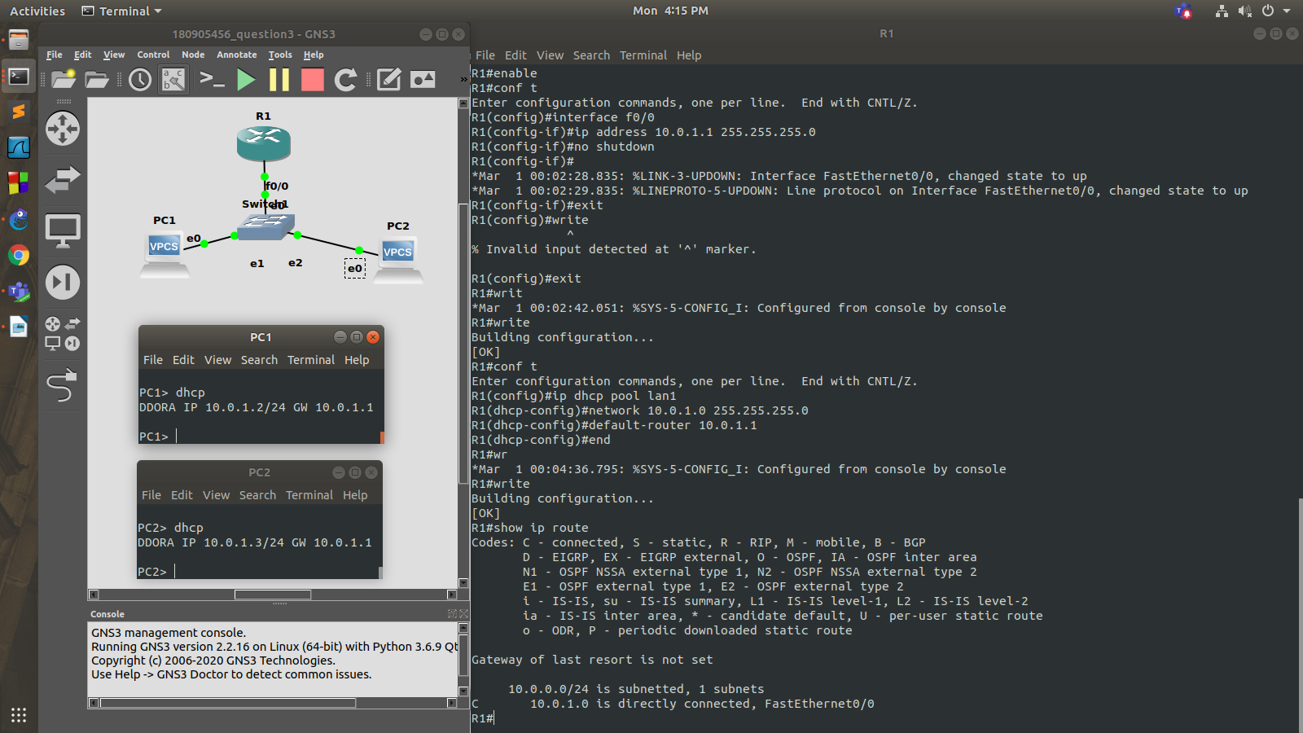

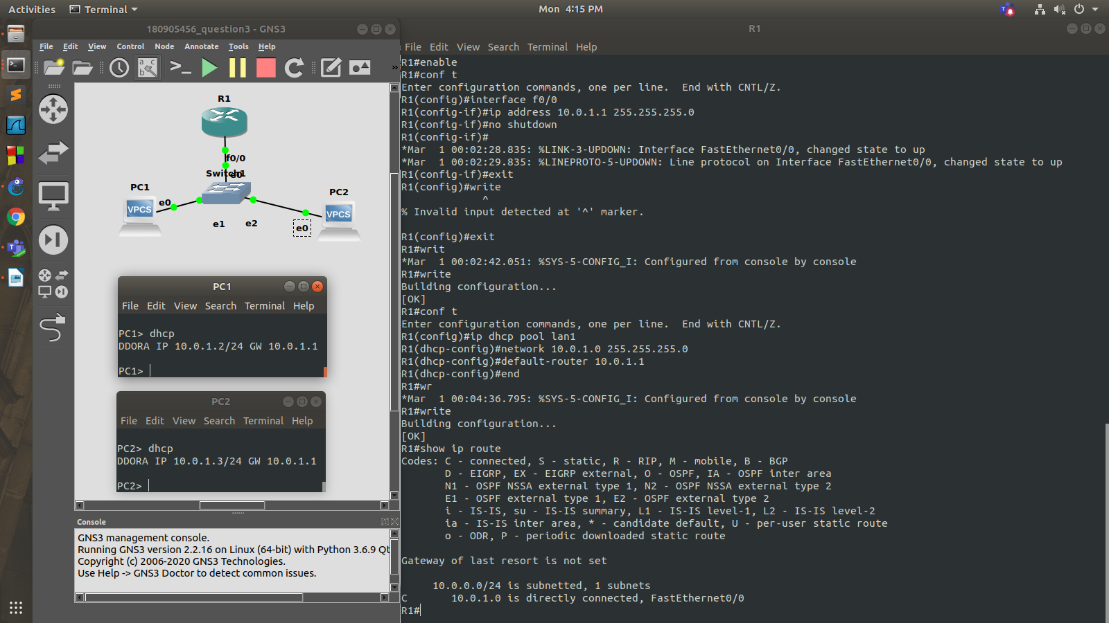

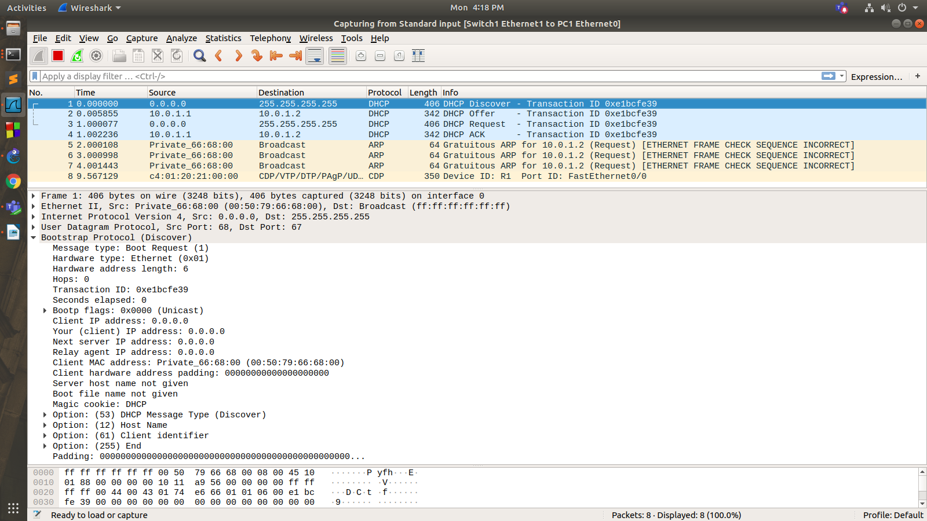

Router configuration

R1#enable

R1#conf t

Enter configuration commands, one per line. End with CNTL/Z.

R1(config)#interface f0/0

R1(config-if)#ip address 10.0.1.1 255.255.255.0

R1(config-if)#no shutdown

R1(config-if)#

*Mar 1 00:02:28.835: %LINK-3-UPDOWN: Interface FastEthernet0/0, changed state to up

*Mar 1 00:02:29.835: %LINEPROTO-5-UPDOWN: Line protocol on Interface FastEthernet0/0, changed state to up

R1(config-if)#exit

R1(config)#exit

*Mar 1 00:02:42.051: %SYS-5-CONFIG_I: Configured from console by console

R1#write

Building configuration...

[OK]

R1#conf t

Enter configuration commands, one per line. End with CNTL/Z.

R1(config)#ip dhcp pool lan1

R1(dhcp-config)#network 10.0.1.0 255.255.255.0

R1(dhcp-config)#default-router 10.0.1.1

R1(dhcp-config)#end

*Mar 1 00:04:36.795: %SYS-5-CONFIG_I: Configured from console by console

R1#write

**Question 2**

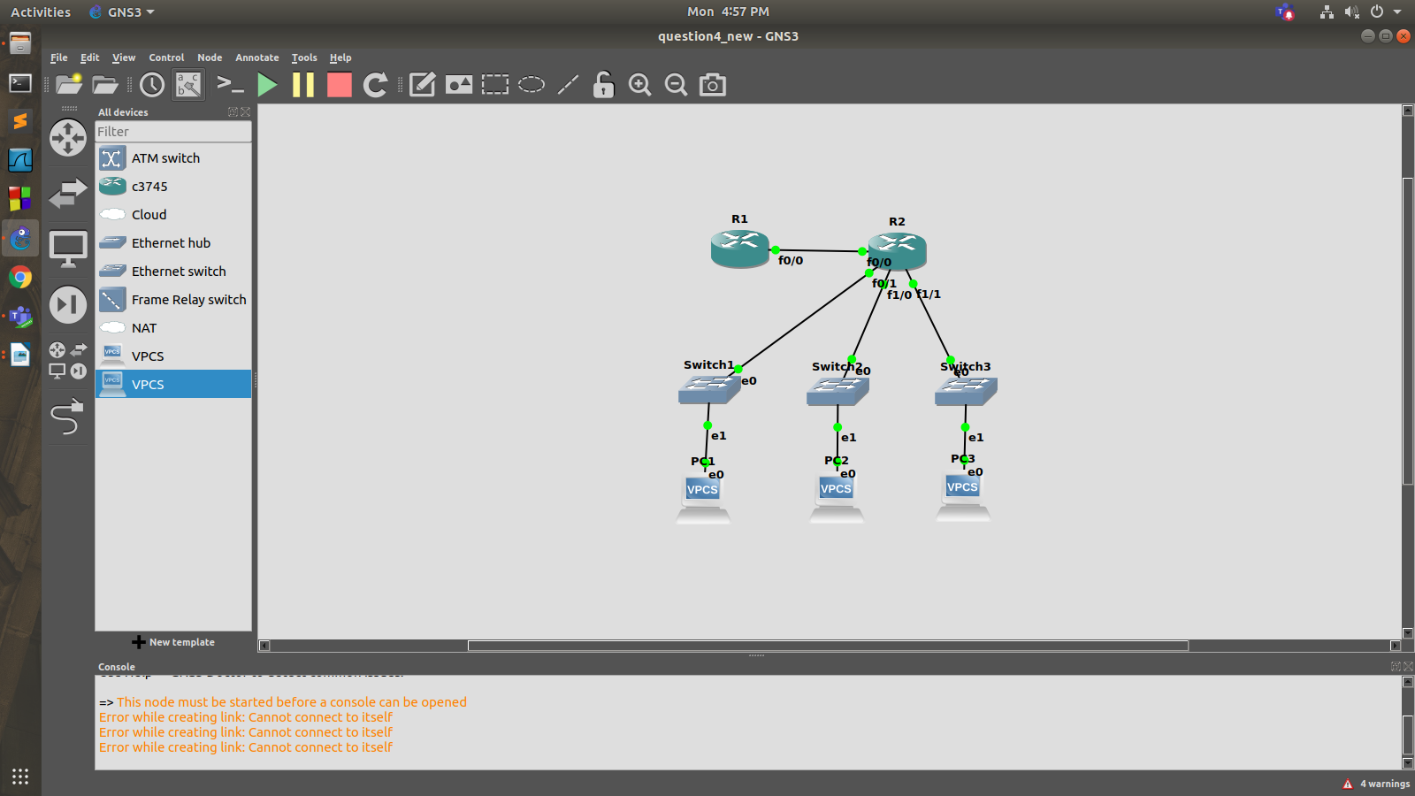

R1:

R1#enable

R1#conf t

Enter configuration commands, one per line. End with CNTL/Z.

R1(config)#ip dhcp pool lan1

R1(dhcp-config)#network 10.0.1.0 255.255.255.0

R1(dhcp-config)#default-router 10.0.1.1

R1(dhcp-config)#exit

R1(config)#ip dhcp pool lan2

R1(dhcp-config)#network 10.0.2.0 255.255.255.0

R1(dhcp-config)#default-router 10.0.2.1

R1(dhcp-config)#exit

R1(config)#ip dhcp pool lan3

R1(dhcp-config)#network 10.0.3.0 255.255.255.0

R1(dhcp-config)#default-router 10.0.3.1

R1(dhcp-config)#exit

R1(config)#ip route 10.0.1.0 255.255.255.0 30.0.0.2

R1(config)#ip route 10.0.2.0 255.255.255.0 30.0.0.2

R1(config)#ip route 10.0.3.0 255.255.255.0 30.0.0.2

R1(config)#exit

*Mar 1 00:03:37.071: %SYS-5-CONFIG_I: Configured from console by console

R1#write

Building configuration...

[OK]

R2:

R2#enable

R2#conf t

Enter configuration commands, one per line. End with CNTL/Z.

R2(config)#int f0/0

R2(config-if)#ip helper-address 30.0.0.1

R2(config-if)#no shutdown

R2(config-if)#

*Mar 1 00:03:02.495: %LINK-3-UPDOWN: Interface FastEthernet0/0, changed state to up

*Mar 1 00:03:03.495: %LINEPROTO-5-UPDOWN: Line protocol on Interface FastEthernet0/0, changed state to up

R2(config-if)#end

R2#wr

*Mar 1 00:03:07.323: %SYS-5-CONFIG_I: Configured from console by console

R2#write

Building configuration...

[OK]

R2#conf t

Enter configuration commands, one per line. End with CNTL/Z.

R2(config)#int f1/0

R2(config-if)#ip add 10.0.1.1 255.255.255.0

R2(config-if)#ip helper-address 30.0.0.1

R2(config-if)#no shutdown

R2(config-if)#

*Mar 1 00:05:05.671: %LINK-3-UPDOWN: Interface FastEthernet1/0, changed state to up

*Mar 1 00:05:06.671: %LINEPROTO-5-UPDOWN: Line protocol on Interface FastEthernet1/0, changed state to up

R2(config-if)#exit

R2(config)#int e2/0

R2(config-if)#ip add 10.0.2.1 255.255.255.0

R2(config-if)#ip helper-address 30.0.0.1

R2(config-if)#no shutdown

R2(config-if)#

*Mar 1 00:06:03.051: %LINK-3-UPDOWN: Interface Ethernet2/0, changed state to up

*Mar 1 00:06:04.051: %LINEPROTO-5-UPDOWN: Line protocol on Interface Ethernet2/0, changed state to up

R2(config-if)#exit

R2(config)#int e2/1

R2(config-if)#ip add 10.0.3.1 255.255.255.0

R2(config-if)#ip helper-address 30.0.0.1

R2(config-if)#no shutdown

R2(config-if)#

*Mar 1 00:06:45.915: %LINK-3-UPDOWN: Interface Ethernet2/1, changed state to up

*Mar 1 00:06:46.915: %LINEPROTO-5-UPDOWN: Line protocol on Interface Ethernet2/1, changed state to up

R2(config-if)#exit

R2(config)#int f0/0

R2(config-if)#ip add 30.0.0.2 255.255.255.0

R2(config-if)#no shutdown

R2(config-if)#end

R2#write

Building configuration...

[OK]

PC1> dhcp

DDORA IP 10.0.1.2/24 GW 10.0.1.1PC3> dhcp

DDORA IP 10.0.3.2/24 GW 10.0.3.1

